**PET 2332 Adapter Rev. 1**

**Testing**

# Test Setup

1. PET 2332 Adapter Rev. 0
2. PET 2332 Adapter Rev. 1
3. CBM8032 (Mainboard ASSY8032030, with CRTC)
4. CBM3016 (Mainboard ASSY320351 Rev. E, without CRTC)
5. A variety of 27C512 EPROMs (120ns)
6. Diagnostic Clip (for CBM80xx)

# Test Execution

## Option ROM in the CBM8032

The Adapter was used for UD11 and UD12 in the CBM8032. The used software was

* VC1541DOS/80 (UD11)
* SM-Kit-B 2.3 (UD12)
* SM-Kit-M 2.3 (UD11)
* EXBASIC V8.1 (UD12/UD11)

The software was installed in different ROM banks on the 27C512. Both Revision Rev. 0 and Rev. 1 were tested.

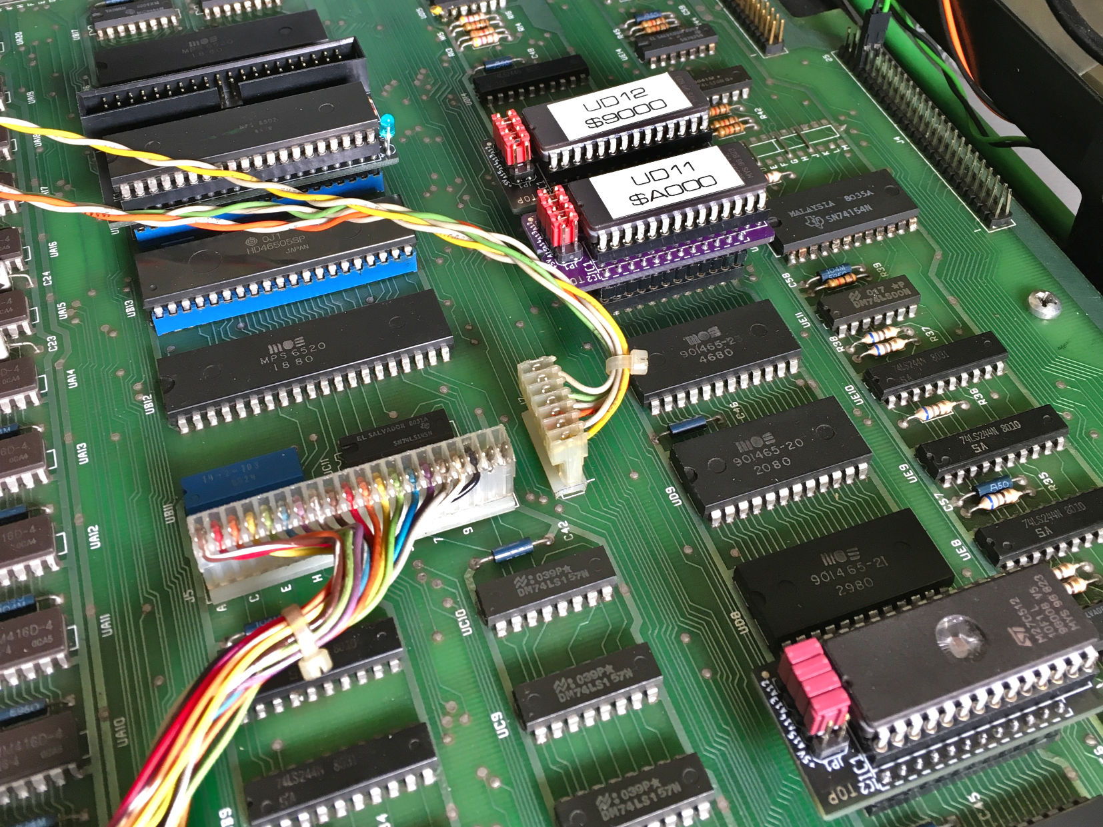

Figure 1: The 2332 adapter in UD11 (v1), UD12 and UD7 (both v0)

Also, the **diagnostic clip**, which males use of the active HIGH chip select pin CS2 (with the /NOROM signal) is working in conjunction with the adapters.

**The adapter and EPROMs worked flawless.**

## Edit ROM in the CBM8032

The software found in the CBM8032, which was used for the test was programmed into a 27C512 and used in the Edit ROM socket UD7.

**The computer worked flawless with this configuration.**

## Kernal ROM in the CBM3016/Dynamic PET2001N-16

The Kernal 901465-03 (BASIC 2) was programmed into a 27C512, inserted into the 2332 adapter Rev. 1 and installed in the socket UD9 for the Kernal.

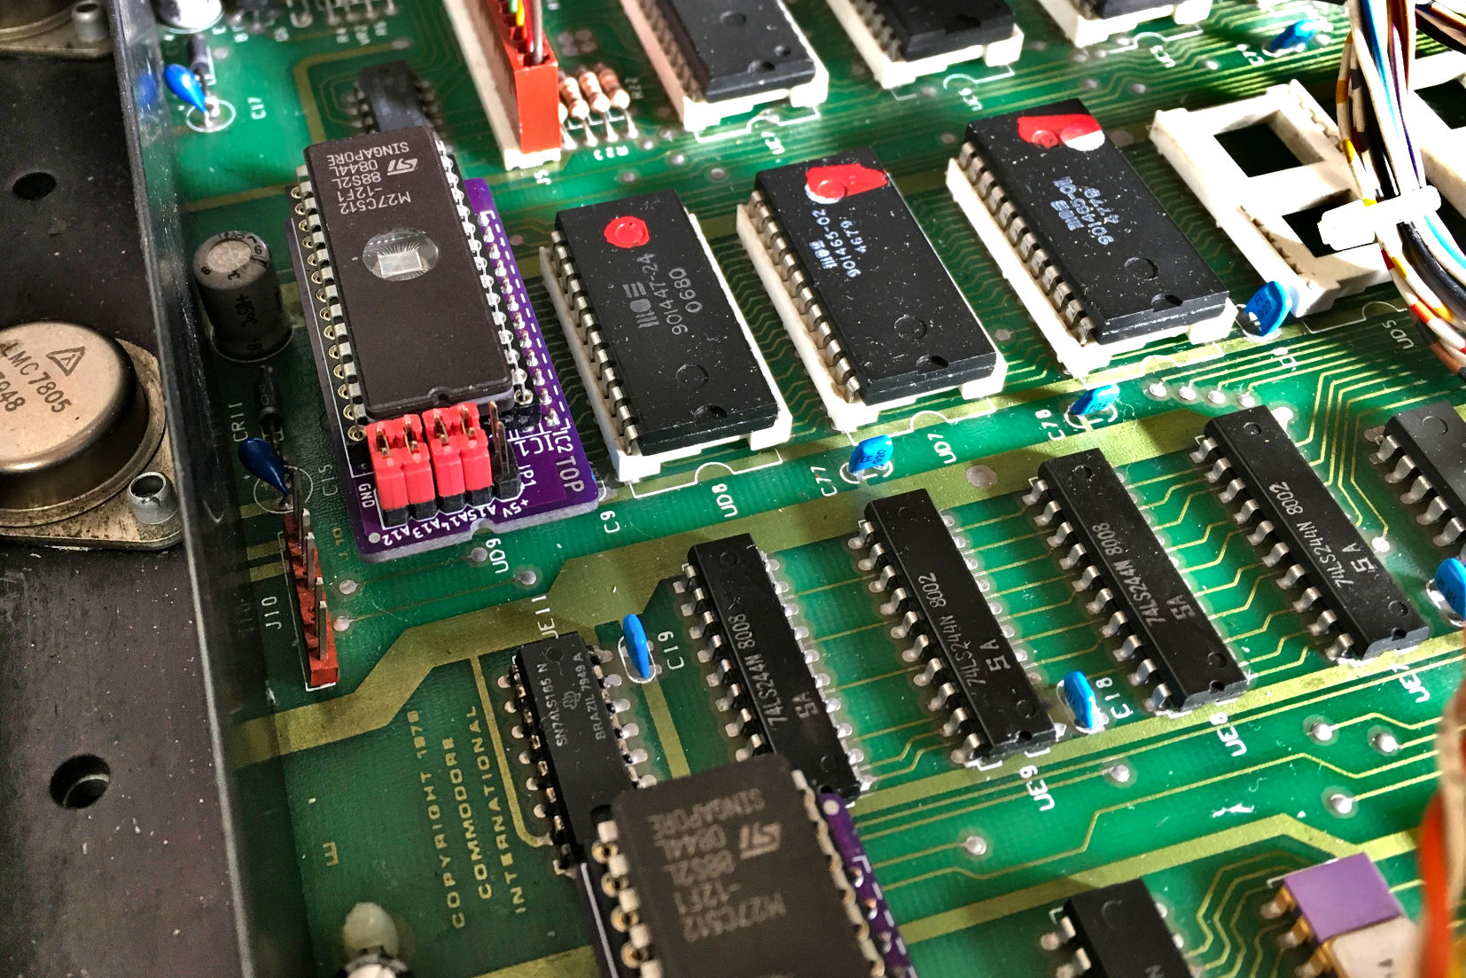

Figure 2: The 2332 adapter v1 in UD9 (Kernal)

**The computer worked flawless with this configuration.**

# Conclusion

The 2332 adapters (Rev. 0 and Rev. 1) are fully functional.